Create volumes :
sudo docker volume create --name jenkins_vision

Run Jenkins with volume :
sudo docker run -ti --name=jenkins_vision -d -p 8086:8080 -v jenkins_vision:/volume_data/jenkins_vision jenkinsci/blueocean:latest

To run this container as Root :
sudo docker exec -u 0 -it jenkins_vision bash [ This is needed if we need to install something inside the container for example to run "apt-get update" "apt-get install gcc" (compiler) ]

Stop any container :
sudo docker container ls [ find id ]
sudo docker stop <<container_id>>

Start the container again without loosing data:
Sudo docker start -ai jenkins_vision [ jenkins_vision is container_id]

---------------------------

Docker useful commands
Sudo docker volume ls [ List all volumes ]
sudo docker ps --filter=volume=<<volume_name>> [ find connected container for this volume ]
sudo docker volume rm <<volume_name>> [ Remove the volume ]
if volume can not be removed [ because container is attached, and its hidden]
-----------------------
sudo docker ps -a [ list all hidden container in docker, and find that with container id]
sudo docker container rm <<container_id>>
Now run : sudo docker volume rm <<volume_name>> [ Remove the volume ]

Sudo docker rmi <<Image_id>> [ Remove image ]

-----
[Listing Images
Listing containers
Listing volumes
look where the volume is connected to ]
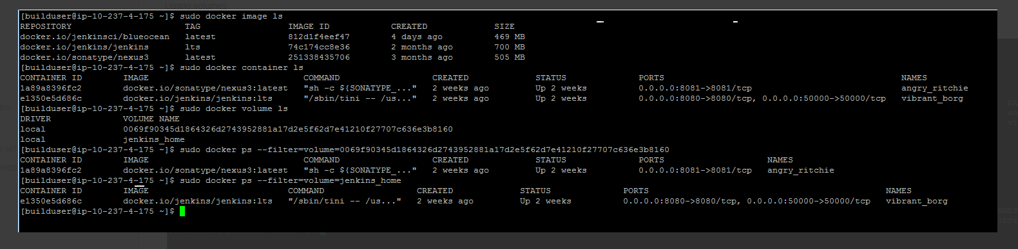
-------------------

$ df [ disk information ]
$ lsblk [ drive detail ]
$ sudo docker mount /dev/xvdb [ mount disc to machine ]
$ sudo docker info [ give information about docker ]
$ sudo docker system df
$ docker system df -v
$ docker system df -v --verbose
----

